PHASE 3 – PROJECT DESIGN

SOLUTION ARCHITECTURE

Project Details

Project Name: AI BlogNest API
Group No.: 6
Team ID: SWTID-2026-8851
Team Lead: Keerthana CK

Team Members:

1. Keerthana CK
2. Kalai Selvi C
3. Kaliswari T
4. Rahima M

---

1. Architecture Diagram

Insert the existing AI BlogNest API Architecture Diagram here.

Figure 1: Solution Architecture of AI BlogNest API

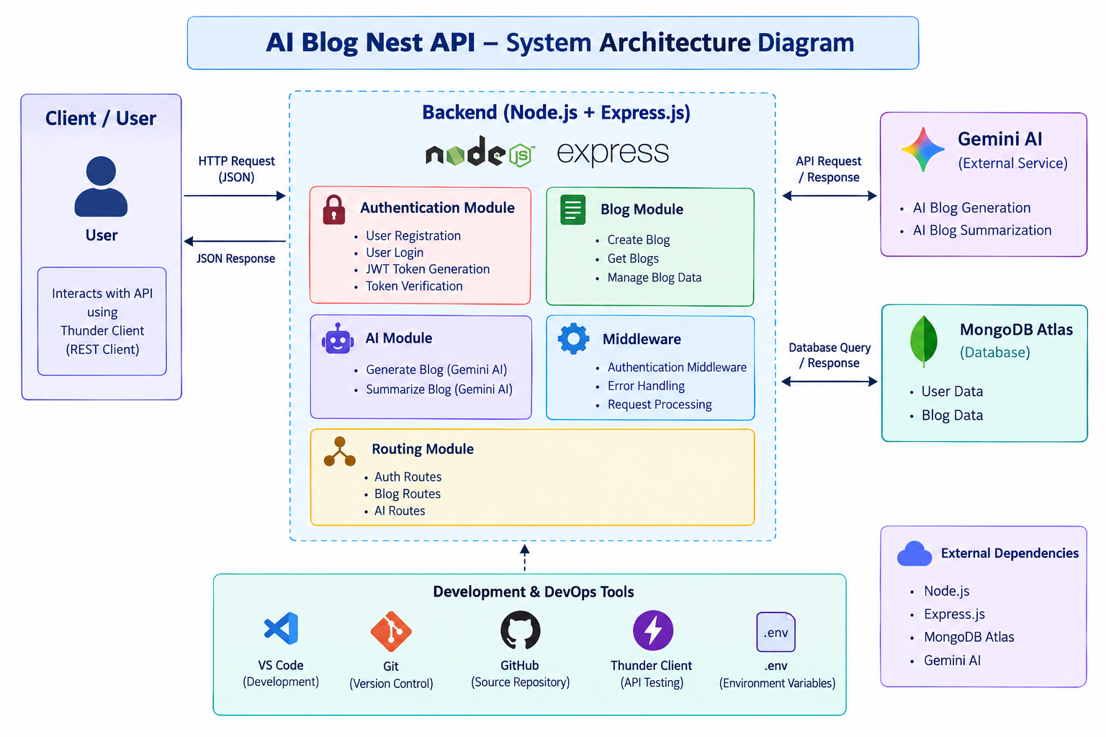

---

2. Architecture Overview

The AI BlogNest API follows a backend-based REST API architecture. The client sends requests to the backend application developed using Node.js and Express.js.

The backend processes authentication and blog-related requests. JWT is used for authentication and protected API access. MongoDB Atlas is used for storing the required application data.

The system also integrates the Gemini AI API to provide AI-powered functionality.

---

3. Component Description

Sno | Component Name | Description / Role in Architecture | Technologies Used
1 | Client / API Client | Sends requests to the backend API and receives responses | REST API Client / Thunder Client
2 | Backend Server | Handles API requests, authentication and application logic. | Node.js, Express.js, JavaScript
3 | Authentication | Handles user authentication and protected API access | JWT
4 | Blog Management | Handles blog-related API functionality including blog creation | Node.js, Express.js
5 | Database | Stores required user and blog-related application data. | MongoDB Atlas
6 | AI Integration | Connects the application with the AI service for AI-powered functionality. | Gemini AI API
7 | API Testing | Used to test API requests and responses during development | Thunder Client

---

4. Data and Request Flow

The basic request flow of the system is:

Client → REST API → Node.js / Express.js → Application Logic → MongoDB Atlas

For authentication:

Client → Login API → JWT Authentication → Protected API Access

For AI functionality:

Client → REST API → Backend → Gemini AI API → Backend → Client

---

5. Database

The project uses MongoDB Atlas as the database and cloud database platform.

MongoDB Atlas is used to store the application data required by the AI BlogNest API.

Database Schema / Collection Details:
[Information Required]

---

6. Architecture Benefits

- Provides a structured REST API backend.
- Supports secure JWT-based authentication.
- Provides centralized database storage using MongoDB Atlas.
- Allows integration with Gemini AI API.
- Separates API requests from backend processing and data storage.
- Supports API testing through Thunder Client.

---

7. Conclusion

The solution architecture provides a structured flow between the API client, backend services, authentication, database and AI integration. The architecture supports the main functionality of the AI BlogNest API while allowing the project to be extended with additional features in the future.

